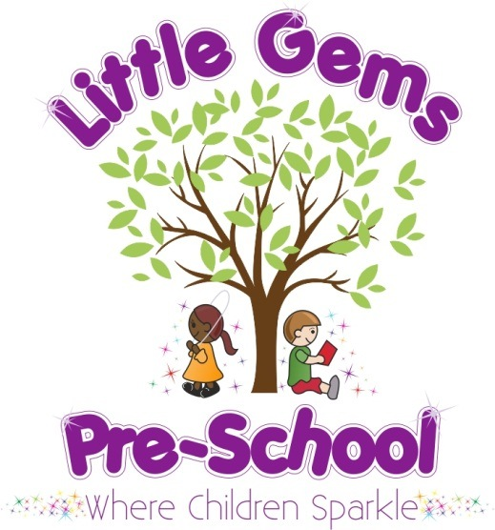

A
P
R
I
L

2
0
2
1

N
E
W
S
L
E
T
T
E
R

Dear Parents/carers,

Our topics for this term will be:

19th April Spring (Letter M, Number 13, Colours Brown, Shape Cuboid)
Our caterpillars arrive this week
26th April Mini beasts (Letter N, Number 14, Colour Purple, Shape Sphere)
4th May Growing (Letter O, Number 15, Colour Black, Shape Pyramid)
10th May Re-cycling (Letter P, Number 16 Colour Gold, Shape Cylinder)
17th May Being healthy (Letter Q, Number 17, Colour Silver, Shape Triangle)
24th May The Farm (Letter R, Number 18, Colour Orange, Shape Square)
Our visiting farm will be with us on Thursday 27th May – (more details will follow)
Upcoming Events and Activities
19th April Caterpillars arrive this week and we will watch them change over the weeks and see what changes happen!
21st April Diddi dance lesson
18th May Planned trip to Paultons Park
27th May Mucky Bucket mobile farm is coming to Little Gems!
25th June Family picnic and sports day event (weather permitting)
22nd or 23rd July Children’s party and leavers event (provisional possible dates)
School Places
For those children who are moving on to school please let us know which school your child will be moving onto so that we can begin making contact with those schools. We realise for some of you, that you didn’t get your chosen school and are disappointed.
Sparkle time sessions
Sparkle time is proving to be really successful and children look forward to their sessions. Sparkle time is our adult led small group times for those children going on to school this year. Sessions so far have included; playing maths games in small groups, recognising and writing numbers, carrying out a floating and sinking experiment, working out how to make a boat for the gingerbread man and planting flowers in our garden. The activities help support their independence, listening and attention, turn taking, following instructions and cover all areas of the EYFS. We have a varied timetable to support children to make good progress and be school ready!
Notices and Reminders
- Due to children with nut allergies and egg allergies, please ensure no eggs (such as egg sandwiches) no peanuts or foods containing nuts are brought into pre-school.
- To avoid choking please ensure grapes and mini sausages are cut lengthwise.
- Please ensure your child has a named coat and suitable footwear for playing outside. Hopefully we will soon see warmer weather so please also ensure your child is wearing sunscreen on these days and provide a named bottle we can keep at Little Gems to assist with top ups at lunchtime.
Paultons Park
Thank you to those who have emailed over the holiday. Please let us know this week how many tickets you will be wanting for the Paultons Park trip. We need 12 paying children in order to be able to go at these reduced rates and we are still falling short of this number at present.
Staffing
Many of you will have noticed that I have only been working at Little Gems one, sometimes two days a week lately. In order to have a better work/life balance I have been working at home doing the admin side of the role in the daytime in order to have some evenings “off”.
Mrs Lorena Boyes will now be taking over the role as Day to Day Manager at Little Gems permanently. Lorena has been working here for over two and half years as Deputy and more recently as Acting Manager and was our Manager at our Wickham pre-school prior to this. Lorena has been working alongside me doing much of the Manager role for sometime to ensure a smooth transition. Our roles in practice won’t actually change very much and so there shouldn’t be any changes to parents or children. I will continue to work at least once a week with the children so I hope to continue to see all of you regularly!
Mrs Renata Allen will continue to be our Deputy Manager and will stand in as Acting manager if Mrs Boyes and myself are absent for any reason.
We are sure the children have mentioned our new staff member Miss Jessica Palmer. We have introduced her to them as Mrs Evans (as she is getting married next month and this will be her married name). She has very quickly become a valued member of our team.
COVID-19
Please continue to socially distance and try to stick to arrival and departure times as per the door/gate allocated and staggered times set to ensure everyone’s safety remains paramount. Please ensure you inform us of any household member who tests positive or if you are self isolating. Please remember, if any household member has symptoms you should all self isolate and a test should be sought for that member and anyone else who develops symptoms.
The staff team have been taking COVID tests every Monday and Thursday morning since 22nd March which we feel adds another bit of reassurance.
Dates for your diary for the year ahead:
2021
Monday 19th April Return to Little Gems
Monday 3rd May Closed – May holiday
Tuesday 18th May Trip to Paultons Park (provided we have enough uptake)
Monday 31st May Closed for half term
Monday 7th June Back to Little Gems
Monday 21st June Inset day closure (in line with St James school)
Friday 25th June Sports day and family picnic lunchtime/afternoon – weather permitting

We are looking to arrange our children’s party and leaver’s event on 22nd or 23rd July. We will keep you informed of this ASAP.
We are looking forward to lots of fun for what will be the last term for some children, making big smiles and lots more happy memories!

Mrs Akins and The Little Gems Team X

