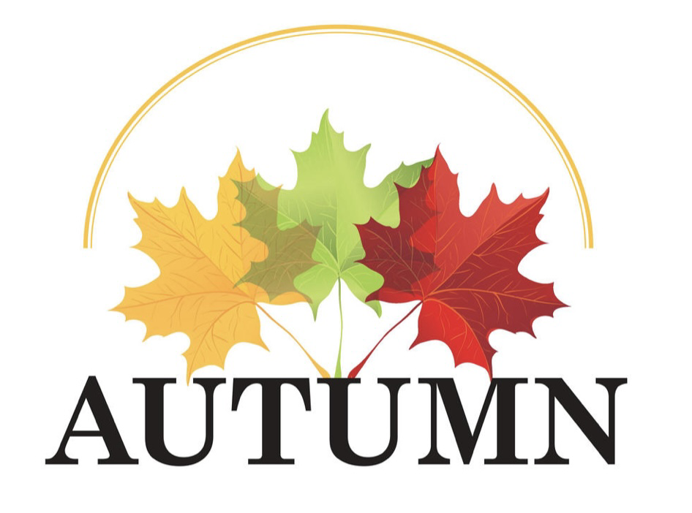

News letter Autumn2022

Welcome back to Little Gems, the children have been getting back into the Little Gems routines and it is lovely to see how much they have grown and come on in confidence over the summer holidays.

We have had a busy start to the term welcoming new children to Little Gems. We would like to welcome the following children to Little Gems this term. We hope you enjoy your time at Little Gems and make lots of new friends; we look forward to watching you all grow.

We love to celebrate how well the children are doing within Little Gems and introduced a wow board to celebrate the children’s achievements. We aim to put up wow moments of something the children have done or achieved within Little Gems which we will share with you on tapestry but also of any wow moments at home, so if your child has done something well please share with us so we can put it on our board and celebrate with the other children.

We like to plan our activities through what the children’s interests are so that the children can be fully engaged and enjoy our learning. Please let your child’s key worker know what your child enjoys doing, so that we can plan these activities into our planning. You can let us know through tapestry, email, text or chatting to one of us in the morning.
Any tapestry from home is always welcome as we love to hear all about the fun things they do at home.

It has been lovely to see the cloak area reopened again since covid and seeing the children in the mornings find their pegs and put all their belongings in the right places and giving them the independence to do things for themselves. Here is a reminder of our new routine.
The gate will be open in the morning for you to bring your children down to the cloakroom. When you get down to the cloakroom, please can you:
- Encourage your child to find their picture and choose a peg to put it on if needed.
- Put Named water bottles on the water bottle trolley
- Named snack pots and bags in the snack box
- Named lunchboxes on the lunchbox trolley
- Named backpacks and coats on their pegs

Please can we ask that everything is NAMED as you can imagine the Children are all into the same thing, so we have a lot of lunchboxes and water bottles the same. Also can we ask that the children’s snacks are also NAMED this can be either written on the packet, or on a bag or little container, as the children do not always know what they have bought in for snack and as we are not putting their snacks in the box anymore, if the snack is not named we have no idea who it belongs too, we would really appreciate your help so that snack times can run smoothly.

A few reminders of what to bring each day:
- Named water bottle
- To avoid choking please ensure grapes, olives, large blueberries and mini sausages are cut lengthwise
- Please make sure snacks are named and kept separately in the snack box and not in their lunchboxes
- We have a no nut policy due to children with severe nut allergies
- Please ensure all belongings are named
- A bag containing spare clothes. Please ensure all clothing is named and that clothing is appropriate for the weather e.g. fleece/jumper/wellies/sun hat, sun team etc.
- Nappies/wipes if needed
- We go outside daily, so please ensure children have a named coat with them.
- If someone different is collecting your child, please let us know that day that it will be as we will not be able to let them leave if we have not been told, due to safeguarding.

Please can we remind everyone that our pick up times are 12pm and 3pm. If you could arrive about 5 mins early it would give staff enough time to see children out and vacate the building at 3pm. This will allow staff to pick up their own children from school and the cleaners can get in to clean the room. Unfortunately if you are more than 5 mins late a late charge will apply. We thank you for your co-operation with this.

Inset days
Autumn term: Friday 2nd December 2022 and Monday 5th December 2022. September 2022- July 2023, there are 5 inset days. Spring and Summer Inset days will be decided in due course.

Term dates
Autumn half term: Monday 24th October 2022- Friday 28th October 2022
Christmas holiday: Monday 19th December 2022 – Monday 2nd January 2023
Spring term starts Tuesday 3rd January 2023
Spring half term: Monday 13th February 2023 – Friday 17th February 2023
Easter holiday: Monday 3rd April 2023 – Friday 14th April 2023
Summer term starts: 17th April 2023
Summer half term: Monday 29th May 2023 – Friday 2nd June
Summer holiday: Monday 24th July 2023

