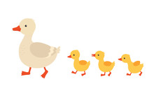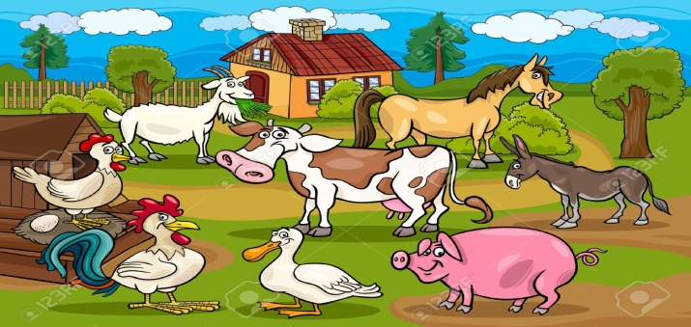
Little Gems Summer term 1 Newsletter: April 2021
Welcome back after the Easter Break, we hope you all had a lovely time and made lots of happy memories and that the Easter bunny left lots of yummy treats.

Over the Easter Break, you would have received an email from Gemma regarding staffing, Sadly Veneta hasn’t rejoined the team this term but I would like to give a very warm welcome to Katie Linham, who used to work with us before and has returned to Little Gems after having a break while she had her daughter. After the May half term we will be welcoming a new apprentice, Michelle Williams, who we are very excited to welcome to the team.
We would also like to take this opportunity to welcome Lyla, Alonzo and Lewis to Little Gems and we hope you have lots of fun and make lots of new friends.

Our topics for this term will be:
Summer term 1: Summer term 2:
19th April: Numbers and Shapes 7th June: Animals (farm visit)
26th April: Numbers and Shapes 14th June: Father’s day
3rd May: Numbers and Shapes 21st June: Summer
10th May: Numbers (insects) 28th June: Summer
17th May: Animals (ducklings) 5th July: Summer
24th May: Animals (pets) 12th July: School
17th July: School

New Resources
The children have really enjoyed playing with the new role play kitchen; we have a new wooden kitchen, sink, fridge freezer and washing machine.

We are still sourcing new technology toys so any suggestions would be most welcome.
To help with new resources we will be carrying out a fund raising event sometime during the summer term and more details will follow shortly.

As this last year has been mainly lockdown and the children have missed out on so many opportunities we have decided that for our animal topic we are going to hatch our own ducklings, they will be arriving on the 17th May and hopefully will hatch by the 19th May and then returning to their forever home on the 27th May. This will be a great opportunity for the children to see the ducklings hatch and watch them grow and change over the short period with us and to learn about how we care for them while in our care.

We also have a visiting farm coming to Little Gems on the 10th June, and we can’t wait to see what they bring for the children to see.

Tapestry
Please continue to share achievements your child has made at home with their key person.
We use tapestry as a tool to track children’s progress through the EYFS and observations, this can be either in written form or photographs. We love sharing photographs of your children and allowing you to see all the things they get up to while in our care.
If anyone is having difficulty accessing tapestry then please speak to Laura or Kim so that we can try to resolve the problem.
Thank you for posting lots of pictures and activities that you have done at home, we love seeing all the fun you have with your children. It’s also a lovely way for us all to work together and to keep in touch.
The team are constantly updating your children’s next steps and we would love to have some feedback from parents so if there is anything you want us to work on while your children are at Preschool, then please speak to your child’s Key worker or ask for a next steps form.

Fees and Funding
Please ensure fees are paid promptly.
As a reminder, fees are payable even if your child is absent due to sickness or holidays.
We are unable to fill the place as the place is reserved permanently for your child and staffing has been arranged accordingly. We do not offer ‘extra’ sessions in exchange for ‘missed’ sessions as part of our policy but have occasionally tried to offer these in the past when we can if children have missed many sessions due to long illness/ family circumstance.
However, as we are now full and into the spring term we will be unable to do this.

Notices and Reminders
- Due to children with nut allergies, please ensure no peanuts or foods containing nuts are brought into pre-school. Thank you.
- To avoid choking please ensure grapes and mini sausages are cut lengthwise.
- To let us know if any contact numbers or addresses have changed
- To speak to any member of the team if you have any concerns at any time.
- To let us know if any medical circumstances have changed for your child such as allergies that we weren’t previously aware of.
- To ensure your child has a named coat and suitable footwear for playing outside. We aim to be outside in most weathers.
- To please have a named snack pot and drink bottle for your child
- To please collect your child at the correct time, unfortunately this has been an issue and late fees will be given to those that are frequently late.
- Please ensure that your child has labelled spare clothes in their bag, also if your child is in nappies or pull up’s please can you ensure we have enough for the sessions and that you provide wet wipes and nappy bags.
- As the weather will hopefully be warming up please can you start to think about putting sunhats and sun cream in the bags too
- Please can all parents ensure that no mobiles are used while at Pre- school, We have a duty to safeguard all the children so please no videoing or taking pictures while near Little Gems grounds.

COVID-19
Due to the current covid situation we will not be changing any aspect of our current practice of staggered arrivals and departures so could I please ask parents to stick to their allocated times. We will still have enhanced cleaning and hand washing practices, as well as the staff being able to have the rapid testing from 22nd March.
We also insist that your child only attends our setting and no other pre-school or nursery to ensure we are all in one ‘bubble’.
Please ensure you inform us of any household member who tests positive or if you are self isolating. Please remember, if any household member has symptoms you should all self isolate and a test should be sought for that member and anyone else who develops symptoms.
Please ensure you maintain a 2m distance from staff members and other parents at all times.
We are also asking all parents and carers to wear face masks when dropping off or collecting their child.
Thank you for helping us to keep the children and staff team safe and well. The children need to be at pre-school and we want to do everything we can to remain open for your little ones.

Dates for the diary for this 2021

Please be aware that we have had to change the inset days by the may half term due to school closure.

Monday 19th April Return to Little Gems after the Easter Break
Friday 28th May Close at 12pm for half term
Monday 7th June 2021 Inset Day
Tuesday 8th June 2021 Inset Day
Wednesday 9th June Return to Little Gems
Wednesday 21st July Close at 3pm for summer Holidays
Thursday 22nd July 2021 Inset day
Friday 23rd July 2021 leaver’s party (School leavers only) close at 12pm

We are looking forward to lots of fun this term, making big smiles and more happy memories!

The Little Gems Team X

