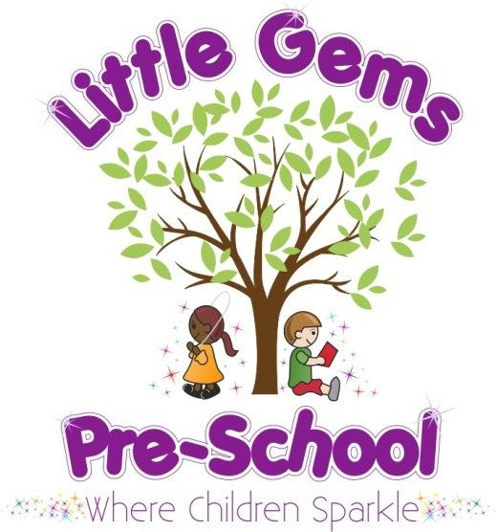

N
O
V

2
0
2
2

N
E
W
S
L
E
T
T
E
R

Dear Parents/carers,
Warm welcome
We hope you all had a lovely half term break, welcome back!
We would like to welcome lots of new children and their families who have joined us this term.
We also welcome back Mrs Kelly Light from maternity leave who will resume her administrative and training co-ordinator position at Little Gems.

Recent Ofsted Inspection
Little Gems was inspected on Friday 7th October.
Thank you to parents who gave some feedback to the inspector.
We have now received the report, it will be published on the Ofsted website in the next 8 days. I am sure you are interested to know the inspectors findings so we attach a copy to share with you today.
We are incredibly proud of the whole team being able to confidently share with the inspector what we do so well at Little Gems. A big thank you to the whole team for their commitment and their enthusiasm to always strive to improve and give the best experiences and outcomes for the children, all the parents for their continuing support and of course the children for being so fantastically brilliant... as always!
The inspector stated verbally to us at the end of the inspection that we were” A secure good in all areas”.
The inspection was a positive experience and it leads us nicely into a full celebratory mood as we head into our sparkly half term and all things Christmas...

Celebrations and Christmas 2022

We are finalising dates of some lovely Christmas events. There will be a Christmas newsletter to follow this week. Please look out for this to enable you to pencil in some important dates in your diary!
We also hope to take part in the St James Christmas Tree Festival this year.

Personal items
Children will need their snack and water bottle in their bag daily
Their lunchbox if they are staying for lunch (please put this in the green crate outside)
Their coat
Please ensure all items are clearly named. Please do not bring other items from home.

Toy sale
Thank you so much for supporting our sale of toys. We hope this has been helpful to you.
This has been a real success. We still have a few items left to sell at our Chandlers Ford pre-school over the next few days, but as soon as we have a total we will let you know how much we are donating to charity and how much will be used to benefit our children at Little Gems.
If there is a children’s charity close to your heart that you would like us to consider donating to, please let us know.
At this time, we are considering Naomi House, Abbie’s Army or Children with Cancer UK.

Little Gems clothing
Please collect and complete an order form or email if you would like to order any clothing. We ask for payment with order please.

(Clothing sizes are age 1-2 years, 3-4 years or 5-6 years)
TYPE | SIZE | COST
T-shirt |  | £6
Polo shirt |  | £8
Sweatshirt |  | £10
*New cardigan | (not available in 1-2 yrs) | £10

Notices and Reminders
- Due to an allergy we are now an egg free zone. Please do not bring egg sandwiches, boiled eggs, scotch eggs etc into pre-school.
- To avoid choking please ensure grapes and mini sausages are cut lengthwise.
- FRUBES – we politely request to not have these brought into pre-school. Children use their mouths to try and open them and they are usually all wet and damaged by the time we are asked to help! They also get squeezed and spill everywhere!
Please send little yoghurt/fromage frais pots and a spoon instead if possible.

Dates for your diary for the year ahead:

2022/2023

Thursday 15th December Last pre-school sessions
Friday 16th December Children’s Christmas party (Finish around lunchtime)

The Little Gems Team X

