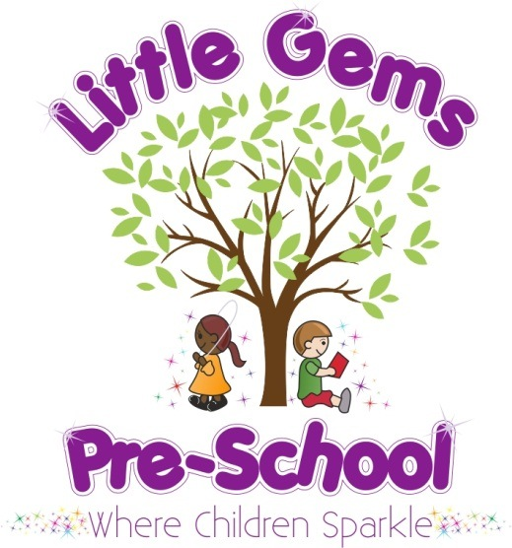

S
E
P
T

2
0
2
1

N
E
W
S
L
E
T
T
E
R

Dear Parents/carers,
Warm welcome
Welcome to a brand new school year at Little Gems!
We hope you have had a lovely Summer holiday despite not seeing quite enough sun!
We would like to welcome some new children and their families who will be joining us this term; Oliver, Reyansh, Elena, Ellis, Leon, Olivia, Theo, Isabelle, Evie and Delilah.
Garden News
A great deal of time, effort and cost has gone into creating a new nature garden for the children over the Summer which has particularly been taking shape these past two weeks. We know the features of the garden will bring some fantastic learning experiences and activities for the children. Due to some delivery issues there a few things not quite ready for Monday and some things are still a work in progress but the children won’t be aware as there will be so many new resources and equipment for them. We can’t wait for them to start exploring!
New features/resources include:
- A new barked area accessed via an archway with a loft den and steps, a bug hotel, a new large mud kitchen, two small world scenery areas, a digger area, sensory plants and planters for growing.
- A large outdoor music wall
- A large outdoor abacus
- Outdoor posters and mirror.
- Many outdoor smaller construction resources and maths resources.
- New slim line storage sheds for the children to access resources from independently.
Please feel free to go down to the garden fence and take a little look!
Topics his term we will be learning about;
Date | Letter | Number | Colour | Shape
6th Sept | A | 1 | Red | Circle
13th Sept | B | 2 | Blue | Oval
20th Sept | C | 3 | Yellow | Triangle
27th Sept | D | 4 | Green | Square
4th Oct | E | 5 | White | Rectangle
11th Oct | F | 6 | Pink | Heart
18th Oct | G | 7 | Orange | Star

We are moving away from topic led activities. Please see our new curriculum & planning policy which explains more.
Changes this term
Due to many rules and guidance around COVID being removed, many things at Little Gems will now be changing. However, some things worked well for the children and their parents. Here is a summary of what we are now going to be doing from 6th September onwards:
Arrival and Departure times
There is no longer a need to stagger start times. However, it does make sense for us to offer two staggered start and finish times, which both offer the full 3 or 6 hour sessions. We ask you to choose your preferred time and email us with this ASAP.
Arrival/pick up times can be either:
Option 1. 8.50am (with a collection time 11.50am or 2.50pm) or
Option 2. 9.00am (with a collection time 12pm or 3pm)
We will no longer be using different entrances - all arrivals and departures will be through the main entrance.
Parents allowed on site on your child’s first day
In the past we had always welcomed parents into Little Gems and we were really uncomfortable with not being able to do so at the start of the pandemic. However we quickly noticed the benefits to the children. Children have settled more quickly and others who find the doorbell and different parents coming in, especially late arrivals very unsettling.
So as a team we have decided it is in the children’s best interests to continue this arrangement of parents not coming into the building and continuing to drop off at the door.
For new children starting we will of course welcome their parents in on their child’s settling in day and first day. We have a new 5 day assessment where parents will be invited in for a brief discussion at this point also.
We will ensure there are times during the year when parents are invited in and we are looking for more ways to improve shared communication between us.
Pre-School Organisation
Many resources that were limited/unavailable to children last year are back at pre-school; such as; shared play dough, pencils, sand, water, dressing up, cushions and rugs, dolls clothes and blankets.
Snack time and lunches will continue to be spread out into two rooms where possible to allow for a more relaxed quieter time to encourage greater communication in smaller groups. We continue to ask parents to provide a snack for their child , already prepared in a named container for them to open independently. Please ensure snacks are labelled and kept separate from their lunch box.
We ask for you to ensure your child has fruit for their snack or another healthy option. Please provide a healthy lunch of a suitable quantity. Lunches should not contain lots of processed or packaged foods or a large number of food items.
The following websites offer really good advice about portion sizes and healthy foods children need.
https://www.firststepsnutrition.org/eating-well-early-years

https://www.foundationyears.org.uk/wp-content/uploads/2017/11/Healthy-packed-lunches-for-early-years-FACT-SHEET.pdf
EYFS
Due to a review of the EYFS, the new reformed EYFS is effective from September 1st 2021. The team have accessed training for this during the Summer term and we are fully on board with the changes. As a result of these changes as a team we have reviewed;
- Our environment - and we have made improvements. We have invested in our outside space and offer a bigger variety of resources unique to the outdoors.
- Our practices – we have looked carefully at our routine and our teaching and we are adapting both to ensure the children are being given the best opportunities to enjoy their learning and make good progress.
- Our curriculum – we have developed a new curriculum and assessment policy which includes our curricular goals for the children, takes into account their interests, builds upon what they already know and can do, and includes a regular cycle of learning and core experiences.
More information about the new EYFS and our curriculm and assessment policy will be emailed to you shortly. As we begin to work within the new framework we are expecting to change and adapt to what works best for Little Gems children and we would like to keep a dialogue with parents as part of this process.

Personal items
Children will need their snack and water bottle daily. Their lunchbox if they are staying for lunch and their own bag of spare clothes (nappies and wipes if appropriate). Coats/sunhats/welly boots as necessary. Please ensure all items are clearly named. Please do not bring other items from home.
If children wish to bring their own bags and fabric lunchboxes, this is okay. However we do prefer the large bags as all their belongings can be accessed easily but all kept together in one place. This has resulted in less items going missing or getting mixed up. Please ensure these big bags are not the really big kind, as they are then too wide for other children’s belongings to fit onto the neighbouring peg!

Hygiene and cleanliness
We will keep up our clear and persistent messages with children about hand washing and good hygiene.
We will continue to clean surfaces, toilets and sinks twice a day.

Little Gems clothing
Please collect and complete an order form or email if you would like to order any clothing. We ask for payment with order please.
(Clothing sizes are age 1-2 years, 3-4 years or 5-6 years)
TYPE | SIZE | COST
T-shirt |  | £6
Polo shirt |  | £8
Sweatshirt |  | £10
*New cardigan | (not available in 1-2 yrs) | £10
Bookbag |  | £7
As always, please come and speak to us, call or email if you have any questions, concerns or ideas. We appreciate communication may not have felt so easy this past year.
Notices and Reminders
- To avoid choking please ensure grapes and mini sausages are cut lengthwise.
- Please ensure snack containers are separate from lunch boxes (not inside the other).
- FRUBES – we politely request to not have these brought into pre-school. Children use their mouths to try and open them and they are usually all wet and damaged by the time we are asked to help! They also get squeezed and spill everywhere! Please do send little yoghurt/fromage frais pots and a spoon instead if possible. (we don’t have spoons here, we will help ensure your child re-packs their spoon to bring home)
- Please ensure your child’s belongings are clearly named, including clothing & water bottles!
- Please do not bring in toys from home (including soft toys). It is difficult to monitor where these are taken/hidden/dropped) and if in their bags they obstruct the children’s access to other things they need.

Fees

Not all fees bills have been sent yet. If you are due to pay fees these will be emailed to you by Tuesday.

Dates for your diary for the year ahead:

2021

6th September Return to Little Gems
22nd October Break up for half term
1st November Return to Little Gems
17th December Break up for Christmas

Mrs Akins, Mrs Boyes and The Little Gems Team X

